Auto-Rentals
Phase 1: High-Level System Design

Requirements Specification
- Functional Requirements
    - User authentication (register, login, logout)
    - Role-based access (renter / owner / admin)
    - Vehicle listing management (CRUD)
    - Search & filtering (location, price, availability)
    - Real-time availability calendar
    - Booking system (create, cancel, confirm)
    - Payment processing (mock or integration-ready)
    - Notifications (email or in-app)
    - Reviews & ratings
    - Admin dashboard
- Non-Functional Requirements
    - Scalability: Handle growing number of users & bookings
    - Availability: 99.9% uptime target
    - Performance: API response < 300ms
    - Security: JWT auth, HTTPS, data validation
    - Usability: Responsive UI (Next.js + Tailwind)
    - Maintainability: Modular backend (Express)
- User Stories
- As a user, I want to register/login so I can access the platform
- As an owner, I want to list my car so others can rent it
- As a renter, I want to search for cars so I can find suitable options
- As a renter, I want to book a car so I can use it
- As a user, I want to see availability so I avoid conflicts
- As an admin, I want to manage users/listings

- Architectural Drivers
- Scalability: microservices-ready structure
- Performance: caching
- Reliability: retries and fallback strategies
- Security: JWT and role-based access (RBAC)

C4 Model Diagrams
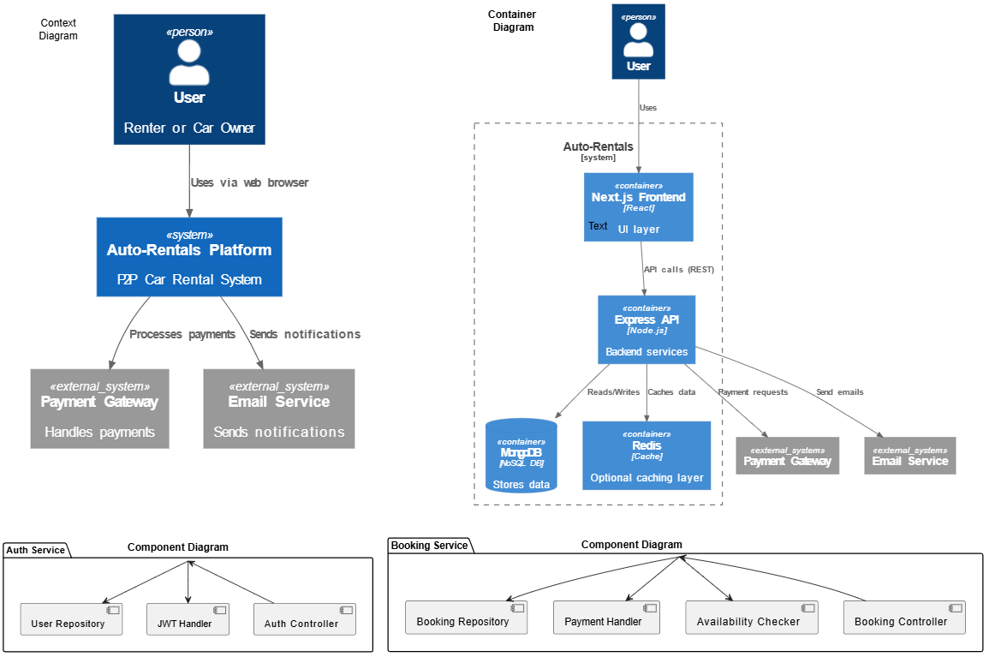

Architecture Decision Records (ADRs)
ADR 001: Backend Framework Selection
- Context: The system requires a backend to handle API requests, business logic, and integration with the database.
- Decision: Use Express.js as the backend framework.
- Consequences:
  - Pros:
    - Lightweight and fast
    - Widely supported
    - Flexible structure for rapid development
  - Cons:
    - Requires manual structuring
    - Can become hard to maintain without discipline

ADR 002: Database Choice
- Context: The platform needs to store user data, vehicle listings, bookings, and reviews with flexibility.
- Decision: Use MongoDB as the primary database.
- Consequences:
  - Pros:
    - Flexible schema for dynamic data
    - Easy integration with Node.js
    - Scales horizontally
  - Cons:
    - Less strict data consistency compared to relational databases
    - Complex queries can be harder to manage

ADR 003: Authentication Strategy
- Context: The system requires secure user authentication and authorization across multiple roles.
- Decision: Implement JWT-based authentication.
- Consequences:
  - Pros:
    - Stateless and scalable
    - Suitable for distributed systems
    - Reduces server-side session storage
  - Cons:
    - Token revocation is harder to manage
    - Require secure handling on the client side
ADR 004: Architecture Style
- Context: The system must support future scalability while remaining simple during initial development.
- Decision: Use modular monolith architecture (microservices-ready).
- Consequences:
  - Pros:
    - Easier to develop and deploy initially
    - Clear separation of modules (auth, booking, vehicles)
    - Can evolve into microservices later
  - Cons:
    - Scaling individual components independently is harder
    - Risk of tight coupling if not properly designed

ADR 005: Frontend Framework
- Context: The application requires a modern, responsive, and SEO-friendly user interface.
- Decision: Use Next.js with Tailwind CSS.
- Consequences:
  - Pros:
    - Server-side rendering improves performance and SEO
    - Tailwind enables fast UI development
    - Strong ecosystem and developer experience
  - Cons:
    - Tailwind can lead to cluttered HTML if not structured well

ADR 006: Caching Strategy
- Context: The system needs to improve performance for frequently accessed data like vehicle listings and availability.
- Decision: Use Redis for caching.
- Consequences:
  - Pros:
    - Reduces database load
    - Faster response times
    - Improves scalability
  - Cons:
    - Adds infrastructure complexity
    - Cache invalidation must be handled carefully

ADR 007: Payment Integration Approach
- Context: The platform requires secure payment handling for bookings.
- Decision: Integrate with an external payment gateway.
- Consequences:
  - Pros:
    - Secure and reliable payment processing
    - Reduces development complexity
  - Cons:
    - Dependency on third-party service
    - Transaction fees apply

ADR 008: Notification System
- Context: Users must receive booking confirmations and updates.
- Decision: Use an external email service with asynchronous processing.
- Consequences:
  - Pros:
    - Improves user experience
    - Decouples notification logic from core system
    - Scalable via queues
  - Cons:
    - Additional service dependency
    - Possible delays in message delivery
ADR 009: Search Optimization
- Context: Users need fast and efficient vehicle search.
- Decision: Use indexed queries in MongoDB with optional search optimization.
- Consequences:
  - Pros:
    - Fast query performance
    - Simple implementation
  - Cons:
    - Limited advanced search features
    - Requires proper indexing strategy

ADR 010: Rate Limiting & Security
- Context: The API must be protected from abuse and attacks.
- Decision: Implement rate limiting and request validation middleware.
- Consequences:
  - Pros:
    - Prevents brute-force attacks
    - Improves system stability
  - Cons:
    - May block legitimate users if misconfigured

API Specifications

OpenAPI – Swagger
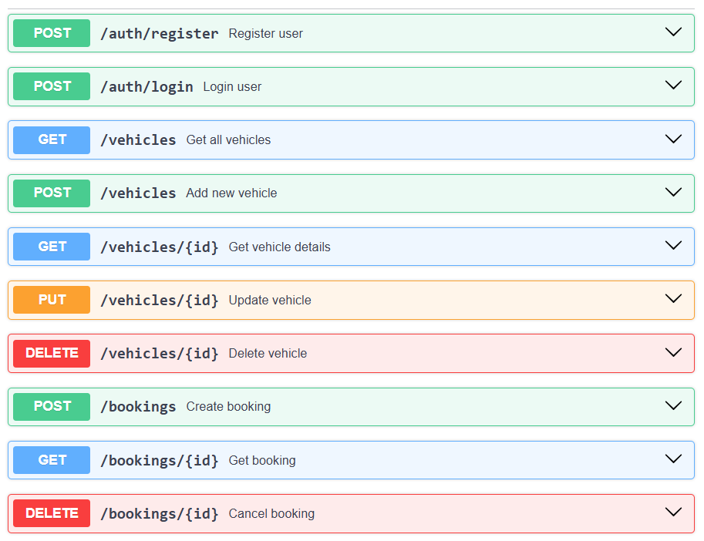
Communication
- Synchronous
  - Frontend → Backend (REST API)
- Asynchronous
  - Booking confirmation → Email queue
  - Payment events → webhook/callback

Resilience Strategies
Retries
- Retry failed payment requests (max 3 times)
Circuit Breaker
- If payment service fails stop requests temporarily
Fallback
- If email fails store notification for retry
Justification
- Prevent cascading failures
- Improve user experience
- Ensure system stability under load

Video link
https://drive.google.com/file/d/1h0uHPd--ArVdo70DL1T3GQsEp3BLzsYa/view?usp=sharing
GitHub Repo link
https://github.com/shadow9-1-1/Auto-Rentals.git

